Place Adjunct

✅ What Is a Place Adjunct?
# Source: AI Source: Provided by: [Data Path: Persons Table -> ID Column: 1, Name_En Column: Motasem Essam] -> From: [Chatgpt (GPT-4-turbo)] on [8/5/2025]
A place adjunct is a word, phrase, or clause that provides additional, non-essential information about where the action of the sentence takes place. It answers questions like:
- Where?
- To where?
- From where?
It is a type of adverbial adjunct that helps set the location or direction of an action or event.

🔸 Common Forms of Place Adjuncts:
# Source: AI Source: Provided by: [Data Path: Persons Table -> ID Column: 1, Name_En Column: Motasem Essam] -> From: [Chatgpt (GPT-4-turbo)] on [8/5/2025]
- Adverbs: here, there, everywhere, somewhere, nowhere
- Prepositional Phrases: at school, in the garden, on the table, near the park
- Noun Phrases (rare): home, abroad
- Clauses: where the accident occurred

🔸 Examples of Place Adjuncts in Sentences:
# Source: AI Source: Provided by: [Data Path: Persons Table -> ID Column: 1, Name_En Column: Motasem Essam] -> From: [Chatgpt (GPT-4-turbo)] on [8/5/2025]
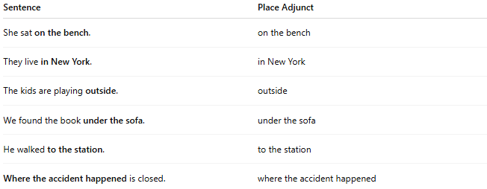
Sentence | Place Adjunct
She sat on the bench. | on the bench
They live in New York. | in New York
The kids are playing outside. | outside
We found the book under the sofa. | under the sofa
He walked to the station. | to the station
Where the accident happened is closed. | where the accident happened

🔸 Position in the Sentence:
# Source: AI Source: Provided by: [Data Path: Persons Table -> ID Column: 1, Name_En Column: Motasem Essam] -> From: [Chatgpt (GPT-4-turbo)] on [8/5/2025]
- Initial: In the kitchen, she found the keys.
- Medial: She has always worked here.
- Final: He slept on the floor.

🔸 Reminder:
# Source: AI Source: Provided by: [Data Path: Persons Table -> ID Column: 1, Name_En Column: Motasem Essam] -> From: [Chatgpt (GPT-4-turbo)] on [8/5/2025]
A place adjunct is optional — it adds helpful spatial context, but the sentence is still complete without it.
🟢 "She sat."
🟡 "She sat on the bench." → Place adjunct added

